Roobric Requirements Spec

# Introduction

## System overview

Many high school English classrooms receive student paper submissions through Google Docs. Teachers grade the paper using a rubric, also on Google Docs, and return the paper to the student. Roobric is a Google Doc add-on that will improve the rubric grading process for high school English courses. The add-on will be free to download from the Google App store. It will feature two modes of operation, one for teachers and one for students.

Teachers will use the add-on to link the associated rubric to a student’s paper. The linked rubric and additional features will be available in a sidebar on the Google Doc. After linking the paper, they will be able to associate comments with rubric categories, fill out the rubric, convert the rubric grade to a percentage grade, and insert the completed rubric into the student’s paper.

Students will use get a customized report used to review the results. The report will display the rubric grades, and comments colored to emphasize which category they are linked to.

## Definitions, acronyms, and abbreviations

|  |  |
| --- | --- |
| **Term** | **Definition** |
| Teacher | High school English teacher |
| Student | High school student in an English course |
| Google Docs | Google’s interactive word document software |
| Rubric | Grading standards for a paper assignment |
| Paper | A student-submitted paper for an English assignment |

Table 1 - Definitions, acronyms, and abbreviations

# Overall Description

## Product perspective

Roobric is a google add-on used by teacher. The add-on will be used to form the link between the rubric and paper, and grade the paper using the rubric. Data related to the grading will be stored in a spreadsheet related to the rubric. The add-on will produce a report based on the grading for the student to review.

The teacher add-on will be opened in the paper and link it to the rubric. A Google Doc document selector will be used to find the associated rubric with a familiar file selection window. A spreadsheet will be created at this time if there isn’t already one linked to the rubric. We will store the link to the rubric, link between comments and categories, and final rubric results in the paper. Modifications to the rubric in the add-on will be stored in the spreadsheet.

Figure 1 - Block diagram

The student report will be a pdf generated from the add-on. It will display the fully graded rubric and the comments colored to reflect their links to categories.

## Product functions

### Teacher add-on

The teacher add-on revolves around grading the paper with the assistance of the rubric. When the add-on is loaded while a paper is open it will prompt the teacher to associate a rubric with the paper. When the rubric is first used a spreadsheet will be created to store relevant information. If a rubric is already associated it will load that one. The rubric will be imported into the sidebar and grouped by the categories. Each category will have a customizable tag used to associate comments with the category. The categories will be editable in case any adjustments need to be made to the imported results.

When a comment is inserted into the paper, the teacher will be able to associate the comment with a category from the rubric by entering the tag into the comment. This action will form a link between the comments and categories of the rubric.

After reviewing the paper, the grades can be entered into the rubric on the sidebar. Once the all of the sections of the rubric are graded the rubric score will be converted into a grade percentage. The finalized rubric can be submitted and a student pdf report generated. On submission the links to the student’s paper and report will be inserted into the spreadsheet along with the final grade.

### Student report

The student report revolves around the review of their graded assignment. The report will be generated as a pdf stored on google docs. The document will contain the fully graded rubric, in addition to the student’s paper. The teacher edits and comments will be maintained, and emphases will be added to the comments. They will be colored to display which rubric category they are linked to.

## User characteristics

Both the students and teachers will be experienced in using google docs in a classroom environment. However, they may not be experienced with using custom add-ons. They will have access to both computers and internet while in school, but outside of school they may have limited access.

## Constraints, assumptions, and dependencies

The imported rubric will be assumed to be a table following a standard format. Specifically the first column, except for the first row, will list the categories of the rubric. These categories could be brief or detailed. The first row, except for the first and last column, will list the point score for the categories. The other cells in the table will contain descriptions of the different point scores for the category.

|  |  |  |  |  |  |  |
| --- | --- | --- | --- | --- | --- | --- |
| **Reading and Writing Standards** | **0**  **(50%)** | **1**  **(65%)** | **2**  **(75%)** | **3**  **(85%)** | **4**  **(100%)** | **Points** |
| **Thesis Statement**  The thesis statement makes a clear argument about the meaning of the poem as a whole.  (10 pts)  (W. 9-10.1A) | The thesis statement is unclear or missing.  (5) | The paper includes an ineffective thesis statement and does not attempt to make an argument about the meaning of the poem as a whole.  (6.5) | The paper uses a somewhat effective thesis statement and attempts to make an argument about the meaning of the poem as a whole.  (7.5) | The paper uses a strong thesis statement and and makes an argument about the meaning of the poem as a whole.  (8.5) | The paper uses a strong and sophisticated thesis statement that makes a clear argument about the meaning of the poem as a whole.  (10) |  |
| **Supporting Evidence**  Develop thesis and identified literary devices with well-chosen, relevant, and sufficient evidence from the poem.  (20 pts)  (RL.9-10.1) | The paper uses little evidence and does not effectively use quoted or paraphrased information.  (10) | The paper uses little evidence. Evidence is incorporated relying too heavily on direct quotes or paraphrased information, sometimes ineffectively.  (13) | The paper uses effective evidence.  Evidence is incorporated through the use of direct quotes and paraphrased information, though occasionally used ineffectively.  (15) | The paper uses well-chosen evidence incorporating it through the use of direct quotes and paraphrased information in an effective way.  (17) | The paper uses well-chosen, sophisticated evidences, incorporating it through the use of effective direct quotes and paraphrased information.  (20) |  |
| **Literary Devices and Analysis**  Develop thesis with analysis of   how the literary devices enhance the meaning of the work as a whole.  (20 pts)  (RL.9-10.4) | Literary devices were not identified and no analysis was attempted.  (10) | One or more literary devices were identified, but their development was not analyzed or related to the meaning of the poem as a whole. Primarily plot summary.  (13) | One or more literary devices were identified, but their contribution to the meaning of the work as a whole was not thoroughly analyzed.  (15) | Two or more literary devices were identified. Their contribution to the meaning of the work as a whole was analyzed, though not well-developed.  (17) | Two or more literary devices were identified. Their contribution to the meaning of the work as a whole was thoroughly analyzed.  (20) |  |
| **…** | … | … | … | … | … |  |

Table 2 - Sample rubric

# Specific Requirements

## User interface requirements

### Teacher interface

In the teacher add-on the linked rubric will be displayed in a sidebar along with the google document. Each rubric category will be stored in its own drop down box. Double clicking on one of the categories will allow the teacher to edit the imported data. Expanding the box for each category will let the teacher select the points for each category. Once a point selection is made the category box will also display the point value.

Next to each rubric category, there will be a customizable tag. This tag will be used to link comments to their associated category. Comments can be linked to categories in the rubric through adding the text “#tag”.

Once points are selected for each category the final grade will be displayed and the submit button will become enabled.

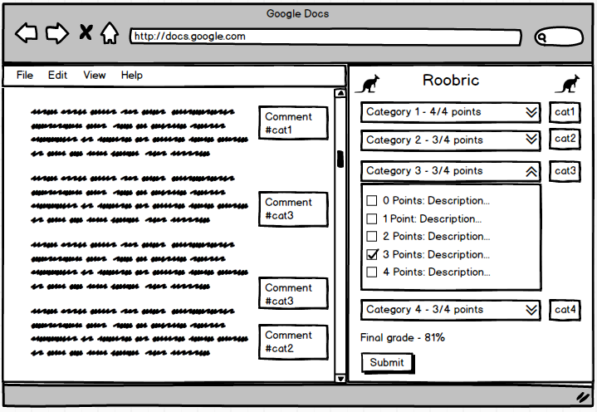

Figure 2 - Roobric add-on

### Student report

The student report will be a pdf generated from the add-on. The report will display the final report and graded rubric at the top of the document. The categories of the rubric will be highlighted different colors, and comments linked to those categories will be highlighted in those colors as well.

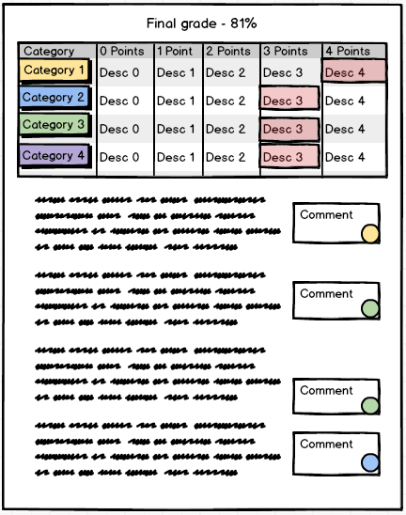

Figure 3 - Student report

## Functional requirements

**ID: FR1**

TITLE: Import rubric (new)

DESC: Upon initially opening the add-on in a paper, the teacher will be prompted to select a rubric from their google docs. The selected google doc will be used to populate the rubric in the sidebar.

RAT: In order to setup the paper for grading.

DEP: None

**ID: --**

TITLE: Create spreadsheet backend

DESC: When a rubric is linked to a paper for the first time create a spreadsheet and link it to the rubric. Create a tab for final grades and a tab for the rubric information.

RAT: In order to store rubric changes and final grades.

DEP: FR1

**ID: FR2**

TITLE: Import rubric (pre-existing)

DESC: When the add-on is opened in a paper which has already had a rubric imported, the rubric data from the last sessions will be loaded automatically.

RAT: In order to grade the paper over multiple sessions.

DEP: FR1

**ID: --**

TITLE: Link spreadsheet backend

DESC: When a rubric is linked to a paper find and link the existing spreadsheet backend linked to the rubric.

RAT: In order to store rubric changes and final grades.

DEP: FR1

**ID: FR3**

TITLE: Modify imported rubric categories

DESC: Double clicking on one of the rubric categories on the sidebar will make that category editable. The teacher can modify the imported data as necessary.

RAT: In order to resolve any issues with importing.

DEP: FR1, FR2

**ID: FR7**

TITLE: Show/hide rubric scores

DESC: Selecting the arrows by a rubric category will display the point scores and their descriptions.

RAT: In order to see point options for each rubric category.

DEP: FR1, FR2

**ID: FR8**

TITLE: Modify imported rubric point scores

DESC: Double clicking on one of the rubric point scores on the sidebar will make that point score editable. The teacher can modify the imported data as necessary.

RAT: In order to resolve any issues with importing.

DEP: FR1, FR2

**ID: FR9**

TITLE: Select point score

DESC: Selecting the checkbox for one of the rubric point scores for that category will assign that point score to that category. This will display the point score on the header for that category.

RAT: In order to grade the paper.

DEP: FR1, FR2

**ID: FR10**

TITLE: Display percentage grade

DESC: When rubric scores have been selected for every category display the percentage grade.

RAT: In order to grade the paper.

DEP: FR1, FR2, FR9

**ID: FR11**

TITLE: Modify percentage calculation

DESC: Double clicking on the percentage grade will let the user modify how the grades are calculated. (maybe this can be setup in the rubric)

RAT: In order to grade the paper.

DEP: FR1, FR2, FR9

**ID: FR12**

TITLE: Submit rubric

DESC: Pressing the submit button will mark the rubric as submitted for the paper.

RAT: In order to mark grading complete.

DEP: FR1, FR2, FR9

**ID: FR13**

TITLE: Import rubric into paper

DESC: When pressing submit a copy of the rubric will appended to the paper.

RAT: In order to allow students to review results without add-on.

DEP: FR1, FR2, FR9, FR12

**ID: FR14**

TITLE: Send score to google classroom

DESC: When pressing the submit button also send the school to google classroom.

RAT: In order to improve grading workflow for teacher.

DEP: FR1, FR2, FR9, FR12

**ID: FR15**

TITLE: Import rubric (submitted)

DESC: When opening the student version of the add-on, if a rubric has been submitted for the paper it will be loaded into the sidebar.

RAT: In order to allow student to review grading

DEP: FR1, FR2, FR9, FR12

## Performance requirements

**ID: PR1**

TITLE: Import rubric

TIME: < 10 seconds

DESC: The initial importing of the rubric will occur when the add-on is loaded and will be accompanied by loading icon. This can take up to several seconds since the user will be transitioning to a new workflow.

**ID: PR2**

TITLE: Link comment to category

TIME: < 1 seconds

DESC: Comments may be linked to a category when it is initially created. Since a new text field is being loaded this doesn’t need to be instantaneous.

**ID: PR3**

TITLE: Highlighting associated categories and comments

TIME: < 0.1 seconds

DESC: During the review process users will be selecting categories and comments to see how they are connected. This should be an instantons action to help the user establish these connections.

## System attributes

### Reliability

The data entered by the teacher into the rubric and comments should not be able to be removed except by them. This is necessary to ensure accurate grading.

### Availability

This add-on should be available 24/7 since google docs is always available and teachers and students may be accessing papers at any time of the day.

### Security

When using the add-on only teachers should be able to edit the rubric scores for the paper. Students shouldn’t be able to edit their results and should only be able to see the results for their own paper.

# Prioritization and Release Plan

## Frist release – Essential features

|  |  |  |
| --- | --- | --- |
| **Feature ID** | **Title** | **Estimate (hours)** |
| FR1 | Import rubric (new) | 2 |
| FR2 | Import rubric (pre-existing) | 4 |
| FR7 | Show/hide rubric scores | 1 |
| FR9 | Select point score | 1 |
| FR12 | Submit rubric | 2 |
| FR15 | Import rubric (submitted) | 1 |
| PR1 | Import rubric | 1 |

## Second release – Primary features

|  |  |  |
| --- | --- | --- |
| **Feature ID** | **Title** | **Estimate (hours)** |
| FR4 | Link comment to category | 4 |
| FR5 | Highlight associated rubric category | 4 |
| FR6 | Highlight associated comments | 4 |
| FR3 | Modify imported rubric categories | 1 |
| FR8 | Modify imported rubric point scores | 1 |
| FR13 | Import rubric into paper | 1 |
| PR2 | Link comment to category | 1 |
| PR3 | Highlighting associated categories and comments | 1 |

## Third release – Auxiliary features

|  |  |  |
| --- | --- | --- |
| **Feature ID** | **Title** | **Estimate (hours)** |
| FR10 | Display percentage grade | 2 |
| FR11 | Modify percentage calculation | 2 |
| FR14 | Send score to google classroom | 8 |